**SERVO DRIVELINE TRANSMISSION AND FAULT MATHEMATICAL MODEL**

**By S.Ozkucuk**

**Basic Mechanical Relations for Gear System**

$$\sum{T}=Jα →\left(\sum{F}=Ma\right) Newton^{'}s law$$

$$T:torque$$

$$α:angular acceleration$$

$J:the mass moment of inertia$,

(Inertia defines the resistance of an object to change in its angular velocity about an axis of rotation. Inertia opposes change in motion.)

**Gear Box ratio: $N_{GB}=\frac{motor speed}{load speed}=\frac{w_{m}}{w_{l}}=\frac{r_{l} (or n_{l})}{r_{m} (or n_{m})} , n:number of teeth$**

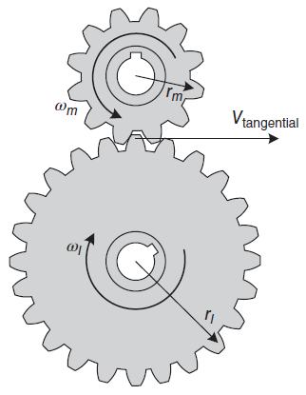

**Fig.1:** Gear Mesh System

The tangential speed equation: $V_{tangential}=w_{m}r_{m}=w_{l}r_{l}$

Power related equation: $P_{m}=T_{m}w_{m} , P_{l}=T_{l}w_{l} →efficiency: \frac{P_{l}}{P_{m}}×100$

$${where, T}_{m}:torque on the motor gear$$

$T_{l}:torque on the load gear$

If we assume the efficiency of the system 100% : $N_{GB}=\frac{w_{m}}{w_{l}}=\frac{r_{l}}{r_{m}}=\frac{n_{l}}{n_{m}}=\frac{T_{l}}{T_{m}}$

**Reflected Inertia**

The reflected inertia is seen by the motor, changes when the load is coupled to the motor through a **direct coupling** or **gear box**.

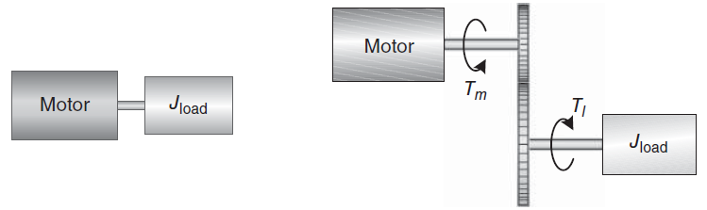

(a) Direct drive (b) Gear box drive

**Fig. 2:** Reflected inertia and torque for (a) Direct drive system, (b) Gear box drive system

Direct drive: $T_{m}=J_{load}{\ddot{θ}}_{m}$

Gear box drive: $T_{l}=J_{load}{\ddot{θ}}_{l} → \left(N_{GB}T_{m}=J_{load}{\ddot{θ}}_{l}\right)$

$$Where, {\ddot{θ}}_{l (or m)}:angular acceleration of the load shaft (or motor shaft)$$

$T_{l}:motor torque transferred to the load through the gears$

For a gear box drive system, when the gears rotate, the distance traveled along the circumference of each gear is the same and given by:

$$r_{l}θ_{l}=r_{m}θ_{m}$$

If we differentiate both sides twice:

$$r_{l}{\ddot{θ}}_{l}=r_{m}{\ddot{θ}}_{m}$$

Solving the equation for ${\ddot{θ}}_{l}$ and substituting into $N_{GB}T_{m}=J_{load}{\ddot{θ}}_{l}$ gives:

$$\frac{r_{l}}{r_{m}}T_{m}=J_{load}\frac{r_{m}}{r_{l}}{\ddot{θ}}_{m} → T_{m}=J_{load}{\left(\frac{r_{m}}{r_{l}}\right)}^{2}{\ddot{θ}}_{m}= J_{load}\frac{1}{N_{GB}^{2}}{\ddot{θ}}_{m} , similarly \left[\sum{T}=Jα\right]$$

Load inertia reflected to the motor through the gears:

$${T_{m}=J_{load}\frac{1}{N_{GB}^{2}}{\ddot{θ}}_{m}=J}_{ref}{\ddot{θ}}_{m} → J_{ref}=\frac{J_{load}}{N_{GB}^{2}}→ J_{ref}=\frac{1}{η} \frac{J_{load}}{N_{GB}^{2}}$$

**Total Inertia:**

$J_{total}=J_{m}+J_{on motor shaft}+J_{ref}$

Where, $J_{on motor shaft} isthe total external inertia on the motor shaft$

${ J}_{ref} is the total inertia reflected to the motor shaft$

${ J}_{m} is motor inertia$

**Reflected Torque**

Power related equation: $P_{m}=T_{m}w_{m} , P_{l}=T_{l}w_{l}→efficiency \left(η\right): \frac{P_{l}}{P_{m}}×100$

We can write:

$$T_{m}=\frac{1}{η}\frac{w_{l}}{w_{m}}T_{l}=\frac{1}{η}\frac{T_{l}}{N_{GB}}$$

**Fault on the Tooth of the Gear System**

**Problem definition:** Gear systems are widely used in servo transmissions with purposes of speed or torque reducer/amplifier or position setting. Such gear systems transfers the motion by friction (teeth) from actuator (servo motor) side to load side. The main problem is, as these gear systems operate, they wear or break mechanically. Or it works with gaps (backlash) between teeth due to assembly errors. These error conditions cause the teeth to slip over each other from time to time. These errors:

-effect main motion profile from motor to load

-create unexpected torque and speed peaks

-reflected torque and inertia are out of order

-increase steady state errors, feedbacks are fails so this effects the controller

-may lock the gears (broken tooth)

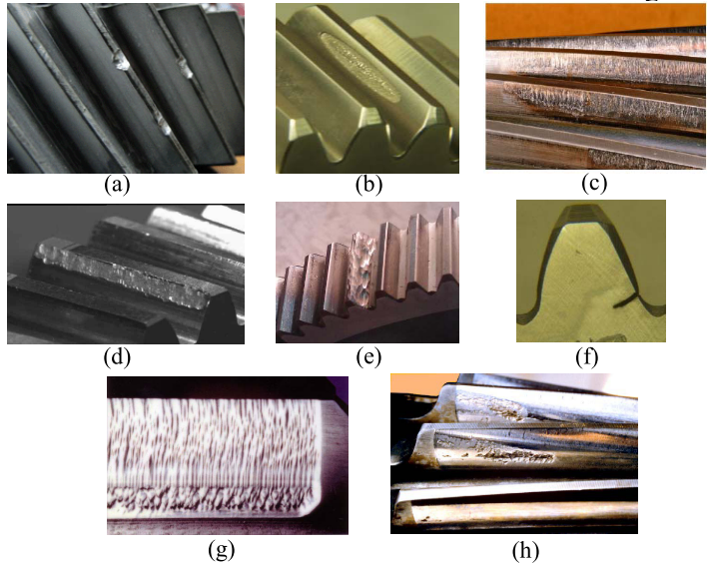

**Assumption for broken tooth model:**

Broken tooth don’t stop the motion. Free moment of inertia continues the motion (there is no locking or complete disconnection)

**Mathematical definitions and representations:**

When the fault occurs on the gear tooth, the equality relation between speed of the motor shaft and load shaft turns to inequality. Mechanical connection and motion transmission between two gears is distorted.

Stable gear system (No fault) Fault gear system (Fault)

$V_{tangential}=w_{m}r_{m}=w_{l}r_{l}$ $V_{tangential}≠ w_{m}r_{m}>w_{l}r_{l}$

$r_{m}θ_{m}=r_{l}θ_{l}$ $r_{m}θ_{m}>r_{l}θ_{l}$

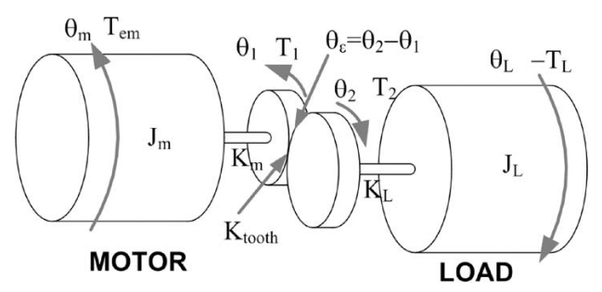

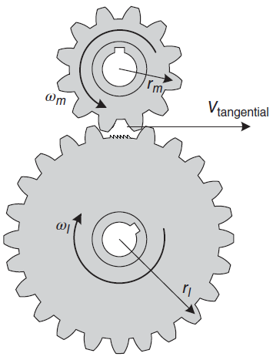

In the servo system we have speed/position (encoder) sensor. If the speed of the motor shaft creates unusual peaks, we can determine the fault condition. For this situation we can create a **β** indicator which defines the inequality between motor shaft gear speed and load shaft gear speed.

For the initial state **β is 1 or 0.**

$β=1$**: System has a gear fault**

$β=0$**: System has no gear fault**

After creating β indicator, we can redefine new inequality with unit step and dirac delta functions. In this case we can redefine the inequality for fault condition with a coefficient term.

$$\left(u\left(t\right)+β×δ\left(t\right)\right) w_{m}r_{m}>w_{l}r_{l}$$

Where,

$β$ is fault indicator coefficient $(0≤β≤1)$, $u\left(t\right)$ is unit step function, $δ\left(t\right)$ is dirac delta function.

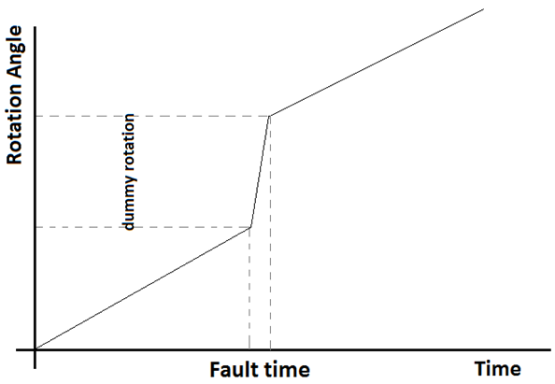

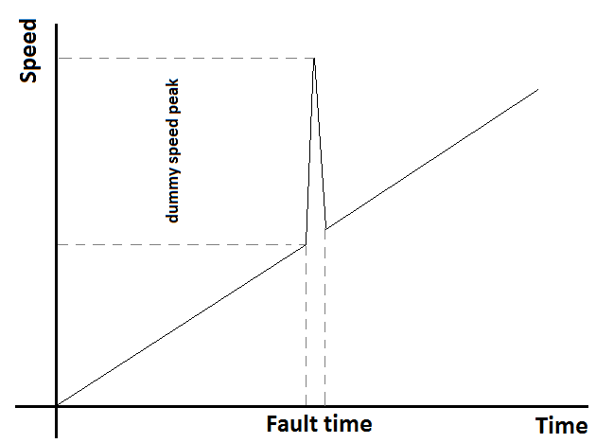

**As seen from figures, $β$**  indicator determines the fault amplitude level. Unit step function provides the no fault condition equality when $β$ is zero.

**Controller algorithm:**

Detection of the speed peak due to fault can be determined by following procedure. Motor shaft speed is tracked by software during maintenance operation time end of the day or daily operation. If the fault occurs, speed of the motor increases suddenly (depends on the Kp coefficient of the PID controller of the speed). So the time derivative of the speed (slope) increases. The main issue is how can we define the sudden change is because of fault or speed command change. To make this distinction, we need to know the speed controller behavior. In a system whose speed is controlled with a PID controller, the speed change is smoother with a torque increasing, while the speed changes are robust in case of a fault and torque is goes to zero. In this case, if the speed is changed by a reference command, the speed changes with torque need. This means that iq current increases. If the speed changes in case of error, the speed increases but the torque goes to zero. This means that iq current decreases.

So we can determine the $β$ indicator value as 1 or 0 with respect to speed and iq change as below. If the two condition satisfied, system have a gear fault.

$$w_{m}\left(t+t_{0}\right)>w_{m}\left(t\right)$$

$$i_{q}\left(t+t_{0}\right)< i_{q}(t)$$

$$t_{0}=\frac{1}{f_{mcu}}×k$$

**Flowchart:**

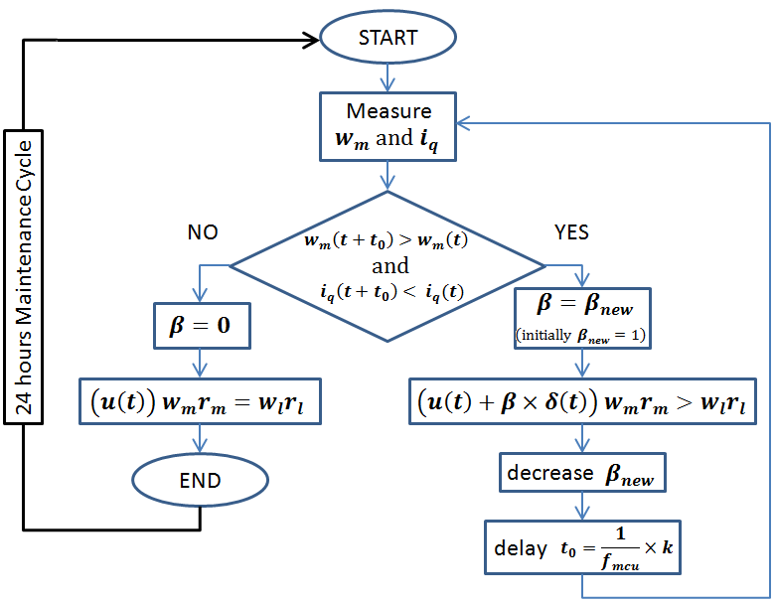

**Speed referenced control system:**

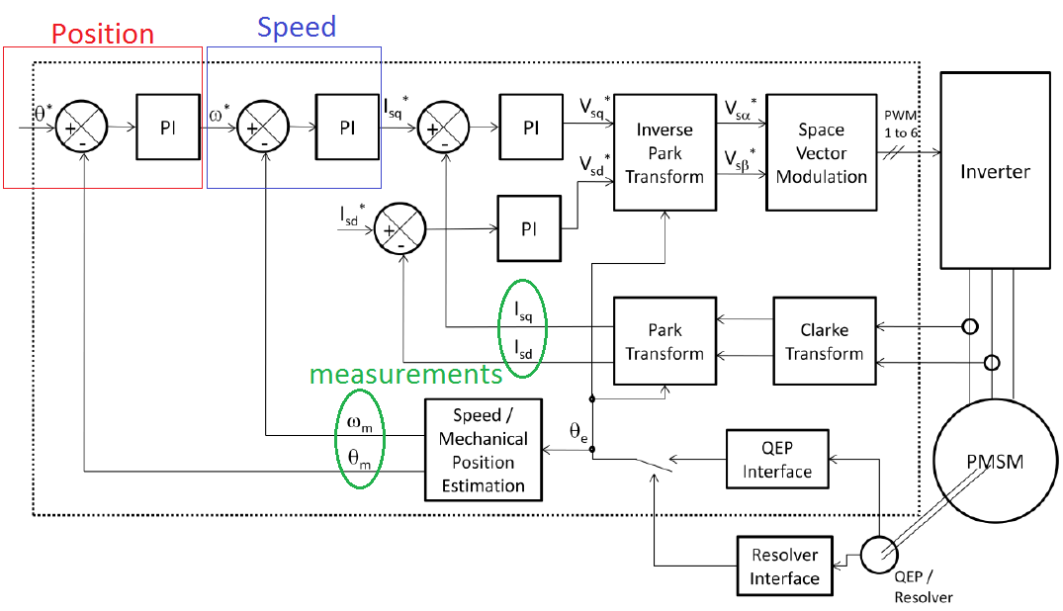

**General FOC system**

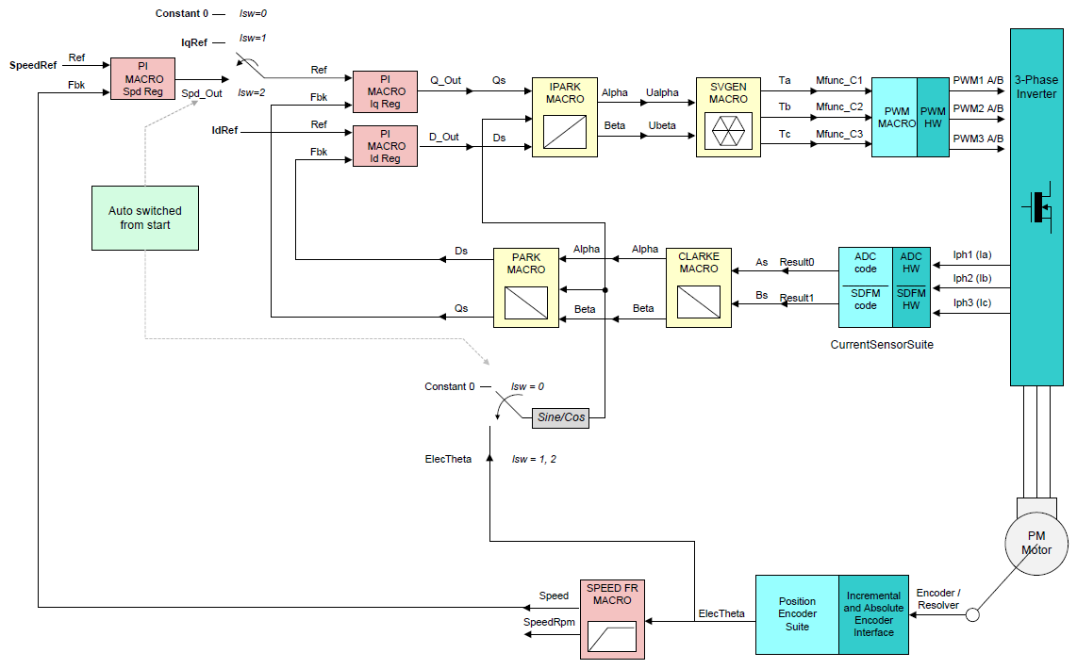

**Speed Control FOC system**

New issues:

Is there any basic measurement for suspecting the fault? Only speed? Only iq? Control bloğundan çekilecek bir parameter ile hata durumu sorgulanabilir mi?

Can we define the system as a no fault and can we END the flowchart?

How can we construct the control block with embedded flowchart?